### A

**Seminar Report on**

**A conceptual model of agumented virtual and reality in cadet training**

In partial fulfillment of requirements for the degree of

### Third Year of Computer Engineering

Submitted By

### Mr. Rohit Bava

Under the guidance of

### Ms. Sushmita Khalane

**For Academic Year 2021-22**

### DEPARTMENT OF COMPUTER ENGINEERING



This is to certify that

#### Mr. Rohit Bava

**[Third Year Computer Engineering] Semester-V**

Has successfully completed his Seminar work on

### ” A conceptual model of agumented virtual and reality in cadet

**training”**

Towards the partial fulfillment of **Third Year Computer Engineering Savitribai Phule Pune University** Academic Year **2022-2023**.

#### (Ms. Sushmita Khalane) (Mr. S.G.Shukla) Seminar Guide Head, Computer Engg. Dept.

**(Dr. N.G.Nikam) Principle**

# Acknowledgement

It is a great pleasure to acknowledge those who extended their support, and con- tributed time and psychic energy for the completion of this seminar work.

At the outset, I would like to thank my seminar guide **Ms. Sushmita** **Khalane**, for her valuable and skillful guidance, assessment and suggestions from time to time improved the quality of work in all respects. I would like to take this opportunity to express my deep sense of gratitude towards her, for her invaluable contribution in completion of this project.

I am also thankful to **Mr.S.G.Shukla**, Head of Computer Engineering Department for his timely guidance, inspiration and administrative support without which my work would not have been completed.

I am also thankful to the all staff members of Computer Engineering Department and Librarian, Guru Gobind Singh College of Engineering and Research Center, Nashik.

Also I would like to thank my colleagues and friends who helped me directly and indirectly to complete this Seminar.

Mr. Rohit Bava

# Abstract

Through digital communication in the educational process, its stakeholders, profes- sors and students, become creators of new information practices, which in involve mod- ern technologies augmented reality (AR) virtual reality (VR). The research objective was aimed at detecting AR and VR information concepts important for determining students’ digital intelligence in the digital creativity domain. In the education of the cadets, some issues have been observed acknowledged, particularly the issues of defining the set of in- formation which is necessary to be transferred to the cadets by AR and VR and the issue of detecting feedback expressed through the learning outcomes previously acquired. The main research challenge is correlation of information sets and how to structure them into a standard cadet training information model. The research was conducted by using the method of content analysis of software solutions and the questionnaire method. The cadets and expert at military academy have been selected as the research sample as they undergo through both the process of acquiring theoretical knowledge as well as practical training. The paper presents the research aimed at VR prototype development and its evaluation with two cadets generations and military professionals, who were introduced to VR technology in different ways. The obtained research results present basis for an AR / VR conceptual model to be further defined, that will contain set of abstract elements, relationships, and information that depict a complex real cadet training system. In this sense, this paper represents an initial step in defining the framework of a standard AR / VR information model in the military training that can be further developed by creating additional categories of data that do not appear in any of the existing information mod- els.

**Keywords:-**Keywords—communication, conceptual model, virtual reality, augmented reality, cadet training, military

# Contents

|  |  |
| --- | --- |
| **Acknowledgement**  **Abstract**  **1 Introduction** | **i**  **ii 1** |
| 1.1 Detail problem definition . . . . . . . . . . . . . . . . . . . . . . . . . . . | 2 |
| 1.2 Justification of problem . . . . . . . . . . . . . . . . . . . . . . . . . . . . | 2 |
| 1.3 Objectives of Problem Statement . . . . . . . . . . . . . . . . . . . . . . | 3 |
| 1.4 Motivation . . . . . . . . . . . . . . . . . . . . . . . . . . . . . . . . . . . | 3 |
| **2 Related Work** | **4** |
| **3 Technical Details** | **6** |
| 3.1 Concept . . . . . . . . . . . . . . . . . . . . . . . . . . . . . . . . . . . . | 6 |
| 3.2 Architecture and Block Diagram . . . . . . . . . . . . . . . . . . . . . . . | 8 |
| 3.2.1 Figure 1: Architecture and Block Diagram . . . . . . . . . . . . . . |  |
| 3.3 Algorithm . . . . . . . . . . . . . . . . . . . . . . . . . . . . . . . . . . . | 9 |
| 3.3.1.1 Figure 2: Agumented Reality Flowchart . . . . . . . . . . . . . . . . | 10 |
| 3.3.1 Result . . . . . . . . . . . . . . . . . . . . . . . . . . . . . . . . . | 10 |
| 3.3.2 Advantages . . . . . . . . . . . . . . . . . . . . . . . . . . . . . . | 11 |
| 3.3.3 Disadvantage . . . . . . . . . . . . . . . . . . . . . . . . . . . . . | 11 |
| 3.3.4 Applications . . . . . . . . . . . . . . . . . . . . . . . . . . . . . . | 12 |
| **Conclusion** | **13** |
| **References** | **14** |

**Chapter 1 Introduction**

By Virtual reality (VR) we mean computer simulations that should create a sense of being present in a virtual environment [1]. These include simulation and real-time interactions across multiple sensory channels [2]. Sensory modalities can be visual, au- ditory, haptic, smell (odor) and taste [1]. The concept of virtual reality has existed for a long time. For a clearer picture of virtual reality, it is crucial to cite the division that has been defined in the research and resolution of the reality question. There are three major types of virtual reality divisions for which some of the main characteristics are listed:

• Virtual Reality, VR;

• Augmented Reality, AR;

• Mixed Reality, MR.

If we look at virtual reality, we can find in it a new, virtual world that we see with the help of specific head mounted devices (like Oculus Rift HTC Vive, OSVR, and others) and, if necessary, use accessories to operate the game console. Furthermore, augmented reality is at any place with the user staying in the real world which is added with digital content. On the one hand augmented reality exposes digital image in the real world and on the other hand, mixed reality shows digital objects housed in the real world. It also allows to tour objects in real space and view objects from all angles [3]. Today VR has numer- ous applications in real life in the following domains: healthcare, military technologies, education, virtual heritage, design and architecture, entertainment and marketing [1]. Military organizations have been investing in VR technology since its inception, as it has been used as simulation training to acquire various military skills [1]. These types of simulations are useful because they reduce exposure in an unsafe environment and can increase concealment [4]. However, training is just one of the many areas where VR technologies are applied. Another example of very useful utilization of VR in a therapy of military personnel diagnosed with post-traumatic stress disorder (PTSD) and other

cognitive disorders [5]. In this regard, this paper seeks to explore new technologies that will enhance military education which is highly complex and demanding, and each part of education seeks to approach a specific realistic task. The idea of military education is in fact to bring all its requirements as close as possible to actual tactical situations within the combat area. Often, such ventures often involve an enormous amount of expense, and are sometimes a great danger to the trainers themselves and the trainees. This paper discusses the application of augmented and virtual reality within the military domain. As such, it enables tactical situations to be created in a very simple way, thereby raising the level of security to the highest level. The paper is structured as follows. First, the theory of augmented and virtual reality is elaborated, technology advantages and disadvantages will be presented, and its general utilization within military domain is described. After that, the idea of AR and VR prototypes developed specifically for the purpose of the research performed within Croatian MilitaryAcademy (CMA) “Dr. Franjo Tuy¨man” is presented with obtained prototype evaluation results. Paper discusses potential of AR and VR prototype as a reference for creating virtual simulations and future solutions in AR technology that could be implemented within cadet education and then within the armed forces trainings.

## Detail problem definition

In the education of the cadets, some issues have been observed acknowledged, par- ticularly the issues of defining the set of information which is necessary to be transferred to the cadets by AR and VR and the issue of detecting feedback expressed through the learning outcomes previously acquired.

## Justification of problem

As when the newly cadets ( Soldiers ) are joined in the army, navy and airforce. Training should be provided to them to assign them different tasks in the working hours and Wars. So to provide them training, we use Model of Agumented virtual and reality. In the education and training of cadets there are many issues that are being solved us- ing AR and VR. We are going to make model of augmented virtual and reality to help soldiers trained in a way that they are in a real word. All the training will be done in

real world in that environment to fully feel the real war and fighting.

## Objectives of Problem Statement

Through digital communication in the educational process, its stakeholders, pro- fessors and students, become creators of new information practices, which in involve modern technologies augmented reality (AR) virtual reality (VR). The research objec- tive was aimed at detecting AR and VR information concepts important for determining students’ digital intelligence in the digital creativity domain.

## Motivation

As in the process of education and training of cadets, it becomes difficult to acquire theoretical knowledge as well as practical training. So to make it easy an AR conceptual model is designed and it shows a complex realistic system of presentation of military equipment. The development of the application prototype is described and the user.

# Chapter 2 Related Work

#### The application of Virtual Reality in military domain:-

There are available simulators for military airplanes and helicopters, within the navy there are ships and submarines simulators, while within the ground forces there are simulators for anti-armor systems, tanks, combat and non-combat vehicles, and even simulators for various types of rifle and self-shotgun shooting

#### Application of Augmented Reality in military domain:-

The first of these is the STE - Synthetic Training Environment or a synthetic training en- vironment which seeks to improve the readiness and ability of soldiers in various tactical environments. It is possible to perform various tactical tasks, that is, to create scenarios with the help of One World Terrain (OWT) [11] where 3D rendering imitates different entities that are placed in the real space.

#### Simulators in the Croatian Armed Forces (CAF):-

Inside the Air Force there is a Full Mission Trainer cockpit installation Simulator A-10, which provides a 3D view of flight and aircraft operations in various situations. In this way, the crew gets a realistic picture of the flight and thus rehearses their actions.

* Simulator VS II - a simulator for training ground forces of the Czech army through the operation, operation and maintenance of combat vehicles such as the T-72 tank and the BVP combat vehicle;
* MUSE GCS UAV - simulator for simulation of work of front observers

# Chapter 3 Technical Details

## Concept

#### Tactical Augmented Reality (TAR):

Remember we mentioned that AR technologies were used for fighter planes? This is where the term “heads-up” display emerged. All the crucial information (spatial orientation data, weapons targeting, etc.) is being superimposed onto the pilot’s visor, so they do not have to look down at their panels all the time and have much better situational awareness. Something like that has been developed by the

U.S. Army Research, Development and Engineering Command’s Communications- Electronics Research, Development and Engineering Center (CERDEC) that are actively researching the potential of augmented reality technology.

TAR looks like the night-vision goggles (NVG), but it can offer much more possi- bilities. It can show a soldier their exact location, and the positions of the allied and enemy forces.

#### HUD 3.0: Another promising helmet-mounted AR display:

At the AUSA Global Force Symposium and Exposition, an event that gathers mem- bers of the industry, military, and academia, a new helmet-mounted augmented reality display was announced, and it is called HUD 3.0. Aiming enhancement, navigation improvement, and virtual training is what HUD 3.0 can offer to the US Army soldiers. However, the field tests of this augmented reality novelty will only begin in roughly a year. There is HUD 1.0, which is also called Enhanced Night Vision Goggles – Binocular (ENVG-B). This AR device provides soldiers with a

better night sight and tactical information (enemy or allied units location, etc.) in the form of an overlay. In addition to that, it has a targeting reticle that is wirelessly linked to the rifle and shows where a soldier is aiming at.

Christopher Donahue, the head of CFT (Cross Functional Team for Soldier Lethal- ity) said that field tests had shown a substantially improved accuracy of the par- ticipants using this augmented reality head-up display. HUD 3.0 will be able to do everything the 1.0 can plus overlapping digital terrain, obstacles, and virtual foes. This feature of augmented reality will allow complicated training scenarios to be run at a much lower cost.

So-called wargames, where troops can fight against one another are quite expensive and therefore are not conducted often.

#### Synthetic Training Environment (STE):

Training is nothing compared to the real combat. When you’re in the heart of a hot zone where gunfire is all around you, it is difficult to stay calm and make the right calls. Spending time in barracks and shooting at 2D cardboard models won’t prepare you for the real actions to the full extent. However, there might be a looming solution provided by augmented reality. Synthetic Training Environment, an AR system that should help train soldiers in a more immersive way, putting them into more physically and mentally stressing operational environments.

The Army Research Laboratory (ARL), University of Southern California Institute for Creative Technologies, Combined Arms Center-Training (CAC-T) and Program Executive Office for Simulation, Training, and Instrumentation (PEO STRI) are now developing the main principles that should govern the STE project. One of the key objectives pursued by the STE developers is to create such a training option that would allow commanders to establish adaptive units with a higher readiness level.

Although there are no prototypes yet, the Army representatives have high hopes that it will be possible to use STE training for any type of combat teams (infantry, aviation, Stryker, etc.).

## Architecture and Block Diagram

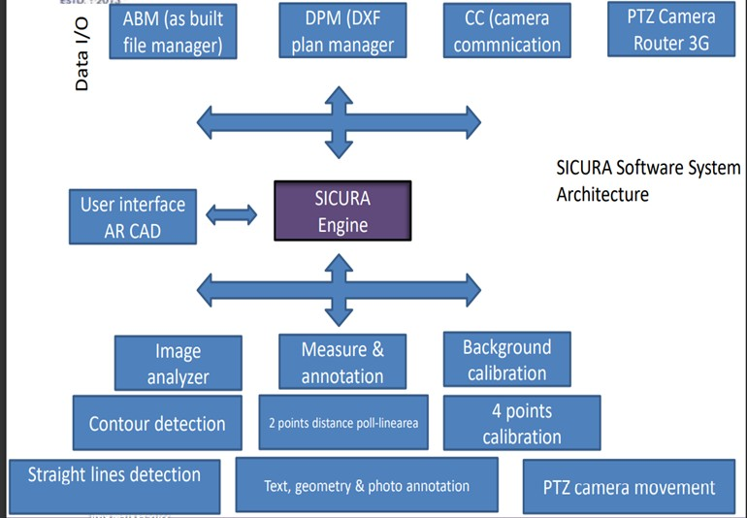

Figure 3.2.1: Architecture and Block Diagram

In System Architecture of augmented reality there are many components which we have to take to comple this system architecture: Background, Scene navigation in AR-CAD, Dy- namical image interaction for AR-CAD, Hardware description like PTZ network camera, AC voltage stabilizer, crane and Software description like “Image analyzer”, “Measure annotation” and “Background calibration”- implement the system functionalities. Data Input/Output modules, Image analyzer, Measure annotation tools

## Algorithm

### Agumented Reality:

#### Virtual Environment and open source logical core :-

* + - * 1. Firstly we have to create a virtual environment to implement the augmented reality in real time.
        2. Then we have to create an Open Source Platform for AR and VR like:

ARToolkit + is open-source and free software that helps solve the fundamen- tal problems in AR and VR.

Holokit is among the top open-source augmented reality tools and virtual re- ality tools that use mobile devices.

BRIO - This platform supports ray tracing. There are a bunch of materials and textures in the BRIO library, which the consumer can use for their models. Plus it is easy to share the BRIO screen online.

#### Data Packets.

* + - 1. **Assembling Data Array (Initial and final position)**

#### Open Source Hardware :-

1. Sensor for rotation.
2. Sensor for orientation.

#### Area for test and compare.

* + - 1. **Displaying section.**

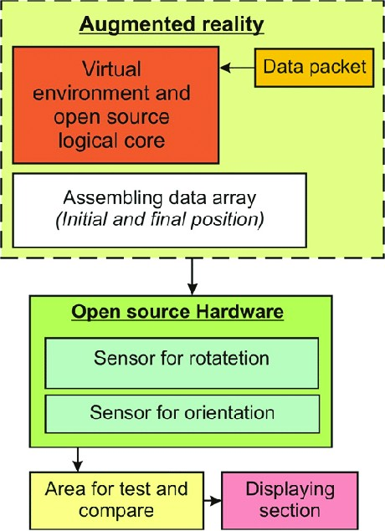

Figure 3.3.1.1: Agumented Reality Flowchart

### Result

By comparing other papers, this paper give best way of Conceptual model of Agumented reality in Cadet Training, This paper gives the all the Components to prepare trainings of cadets in the military, navy and airforce.

### Advantages

1. Augmented reality (AR) is helping military forces evolve MRO by superim- posing digital data, like step-by-step service instructions, into a user’s real- world view—so they can visually identify service needs in 3D
2. By using AR in conjunction with existing CAD data, military forces can visualize and maintain MRO information more efficiently, resulting in a faster, more agile workforce.
3. Technicians equipped with AR are more productive, and employers can scale their expertise to save costs and improve service outcomes.
4. AR-based training helps workers comprehend and retain information faster, so new technicians can learn and execute the complex maintenance activities that will sustain military assets for years to come

### Disadvantage

1. The absence of Input Medium has been a glaring insufficiency in AR Sets. The utilization of consoles and mouse is lacking in an undeniable battle condition.
2. Information Overload can cause a commotion on the Battlefield as in a high- stretch condition, unnecessary information jumbling on the Helmet Screen can be excessively agonizing, making it impossible to break down the outline of what is needful for us and what isn’t.
3. Military is the Depth Perception it provides. Incorrect Depth Perception can hinder a soldier’s capability as they need an unrestricted view to completely realize the threat level.
4. One of the biggest drawbacks of the AR utilization.

### Applications

1. AR can likewise be utilized in other Military Applications other than training soldiers in different orders like preparing Combat Medics in a field of Combat First Aid, preparing Combat Engineers like Sappers and Miners, Military Simulation by summarizing the three-dimensional nature of the earth to the advanced application to consider sensible activity information streaming in through the body wearable sets giving more easy to use information rather than a blend crush of assortment of pointless and helpful information frames, and more.
2. In present, many of the Combat Troopers around the world are trained in Counter-Insurgency and Counter-Terrorism Operations around the world.
3. Most of these operations take place in Urban and Semi-Urban Regions. Aug- mented Reality can be utilized to beef up Trainees in MOUT and Close Quarter Battles with simulated scenarios where the trainees can be pitted in various Combat Scenarios where their Combat Efficiency can be taken a test off.
4. Various Training Facilities around the world have Kill-Houses and Simulated Villages, to allow the operators to take place in simulated Combat Operations.
5. Augmented Reality can simulate a more Realistic Combat Operation by in- volving civilians and non-combatants and also involve opposing forces and simulated munitions to allow the operator believe that he is operating in a Real-World Environment and not in an unrealistic setup.
6. Such a training setup can also help to validate a Soldier’s approach to a particular situation, his reaction time and then study his combat efficiency.
7. Training using an AR System can also help the soldier to share the best prac- tices with his fellow troopers and build their skills upon a common synergy conducive of the Training Purposes. Reality is like a beautiful canvas where we as a painter can do justice to it by painting beautiful colours for our own purposes.

# Conclusion

Emerging technology, such as AR and VR has a great potential of utilization in military education. Although there are numerous solutions in this field, they are under-researched. During the research described in the paper, AR and VR prototypes were developed, with several purposes: to introduce cadets to these technologies, to add value to education given the content of the prototypes, and to motivate in a structure way both cadets and military professionals to reflect about future potential beneficiaries of solutions. Their active involvement in the process of developing any future education solutions based on emerging technology is pre- requisite since they can provide valuable software requirements and ideas how the direct solution design and content to be useful and increase military capacity in terms of improvement of education, interpersonal, technical and conceptual skills. As with any new technology, it is hard for user to reflect on something that has not been in use, so the prototyping and evaluation methodology applied in this re- search provided structured way of fasttracking introduction of user to the emerging technology features.

# Bibliography

1. I. Gae et al. ”A Serious Game VR Prototype for Learning about Military Units based on Unity Platform (project report)”, University of Zagreb Faculty of Electrical Engineering and Computing, 2018.
2. vana Ivanda et al. ”An AR Prototype for Military Academia (project report)”,

University of Zagreb Faculty of Electrical Engineering and Computing, 2019

1. P. Antolovic, “Application of Virtual Reality in the Military Domain,” BSc Thesis, University of Zagreb Croatian Military Academy ”Dr. Franjo Tudman”, 2018.
2. A. Rizzo, M.J. Roy, A. Hartholt, M. Costanzo, Virtual Reality Applications for the Assessment and Treatment of PTSD“
3. E. Malbos , L Boyer , C. Lan¸con, Virtual reality in the treatment of men- tal disorders“, (article in French) L’utilisation de la r´ealit´e virtuelle dans le traitement des troubles mentaux“ (, La Presse M´edicale, Volume 42, Issue 11, November 2013, Pages 1442-1452